G6-S fresh air controller manual
(AC 3-speed version)
- Overview:
G6-S fresh air system intelligent controller can monitor indoor temperature and humidity, PM2.5, CO2 (optional), VOC (optional) and other data in real time; can be connected to WIFI (optional); with ModBus RTU (RS485) interface. Users can connect to backends such as smart homes through the ModBus interface to monitor device status; the output signal of the AC 3-speed controller directly controls the start and speed of the fresh air fan. It can be widely used in residential, commercial and industrial occasions, and can effectively improve air quality to create a healthy, comfortable, efficient, environment-friendly and energy-saving living and working environment.
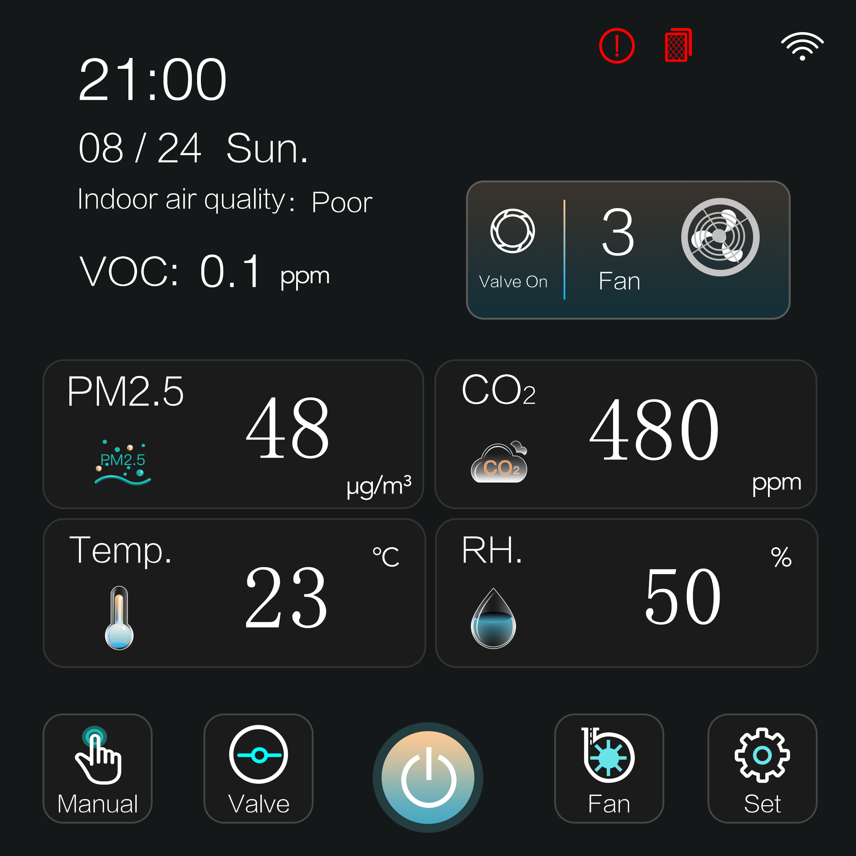
- Function description of touch buttons on the main interface:
1.  : Power on/off
2. 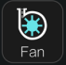 : Fan speed key (stop, low, medium, high, four fan speed states)
3. 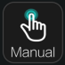 : Working mode key (manual, automatic, timing, three working modes)
4. 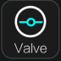 : Air valve key
5. 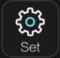 : Setup Menu Key
Note: In the automatic mode, the fan speed is switched according to the sensor data; In the timing mode, the fan is switched on and off according to the timing time. When the timing is the shutdown time, the fan is stopped, the fan operates according to the manual fan speed when the timing is power on time.
3. Display description:
1. Main interface: The main interface is as shown below
Turn on the controller and enter the main display interface, which displays indoor PM2.5; the CO2 (optional) version has CO2 display; the VOC (optional) version has VOC display; the WIFI (optional) version has a WIFI icon display when connected to the Internet; indoor air quality: excellent, good, medium, poor (The air quality level changes according to the secondary interface sensor setting parameters. The larger the sensor data, the air quality will display the air quality level based on the maximum sensor data. The larger the air quality level, the worse the air quality will be);
2. Menu setting interface: as shown below
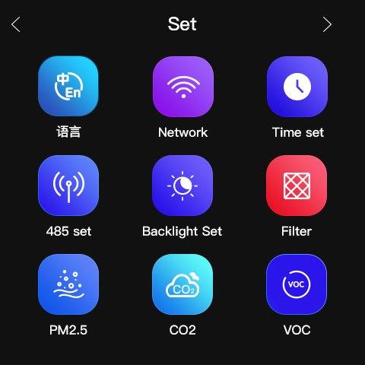
Press the set button in the main interface to enter the setting selection interface. The setting interface includes language selection, backlight setting, WIFI network configuration, time parameter configuration, filter setting, ModBus device address configuration, sensor data configuration under automatic mode control, and fault viewing.
3. WIFI setting interface: as shown below
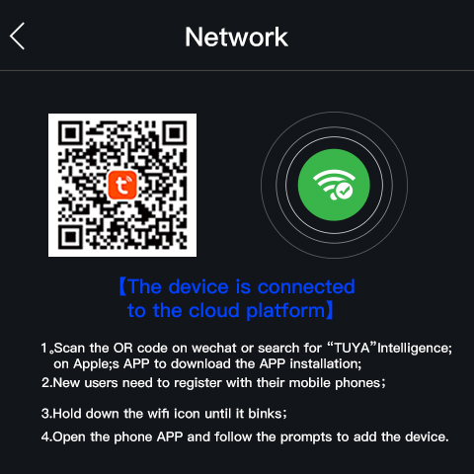
In the WIFI settings interface, use your phone to scan the QR code. Download and install the application, and complete the setting sequence under the guide in the application. Press and hold the network distribution button on the right until the WIFI icon in the network distribution button flashes quickly; Click the "+" at the top right corner of the APP to manually add a fresh air blower. Follow the prompts to enter the connection status. When WIFI is connected to the device, there will be a prompt "The device is connected to the cloud platform" below the QR code.
4.Date parameter interface: as shown below
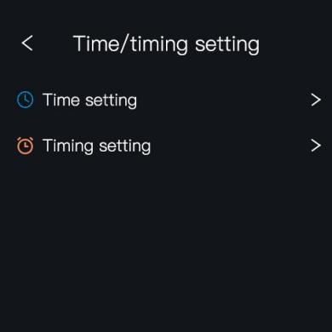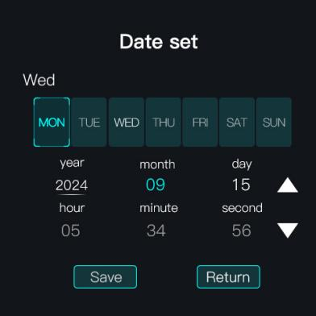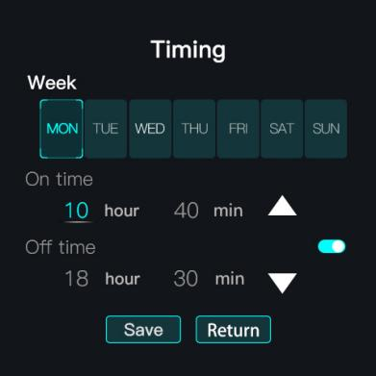
Touch the time to be set on the date interface, and then press the plus and minus keys to modify the time. After the modification is completed, press the save key to save, and press the return key to return to the previous interface.
In the timing parameter setting interface, press Monday to Sunday respectively to select whether to turn on or off the timing state for the corresponding timing time of the week；
If the timing button is turned off, the fan will run at manual speed;
If you turn on the button corresponding to the day of the week, the fan will run at the manually set fan speed according to the startup time and turn off the fan according to the shutdown time. (The timing power-on time and timing power-off time are not to switch the whole controller, but to run the fan and stop the fan).
After setting the timing parameters, press the save key to save and return to the previous interface.
- Backlight parameter setting interface: as shown below
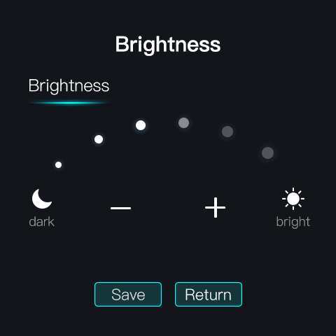
The brightness can be adjusted in the backlight parameter setting interface. After adjustment, press the Save key to save.
- RS485 setting interface: as shown below
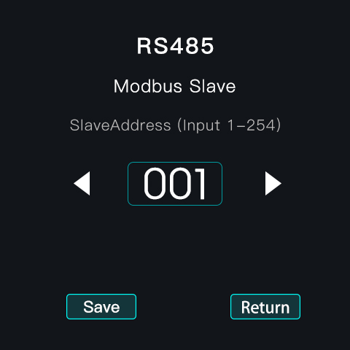
Modbus slave address setting, setting range 1-254, press the Save key to save after setting.
- Filter time setting interface: as shown below
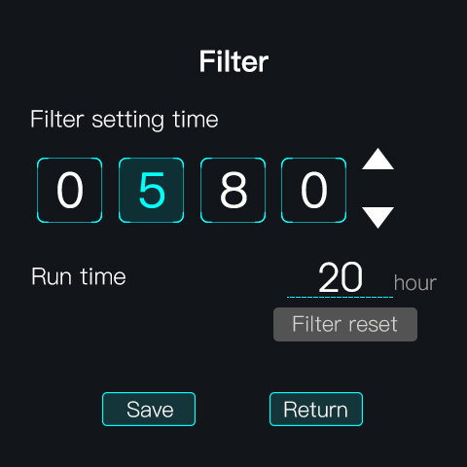
In the filter time setting interface, the filter initial time (filter life) setting range is 1-9999 hours. Displays the working time of the filter. Press the Filter reset button to clear the working time of the filter. If the working time of the filter is greater than or equal to the filter life setting time, a small red filter alarm icon will be displayed in the upper right corner of the main interface.
- CO2 parameter setting interface: as shown below
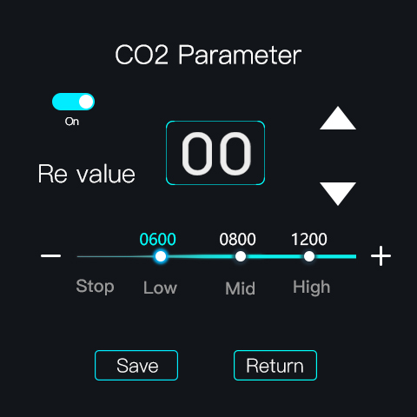
In the CO2 parameter setting interface, set return value，low, medium and high value. When the CO2 value switch button is turned on, the fan will switch to the fan gear according to the CO2 value in the automatic mode. When it is turned off, the fan will not be affected by the CO2 value in the automatic mode.
When the CO2 button is turned on, in the automatic mode, the CO2 value is greater than the set value, the fan operates at the corresponding gear, when the fan speed changes from high gear to low gear, CO2 value should be lower than setting value minus return value.
- PM2.5 parameter setting interface: as shown below
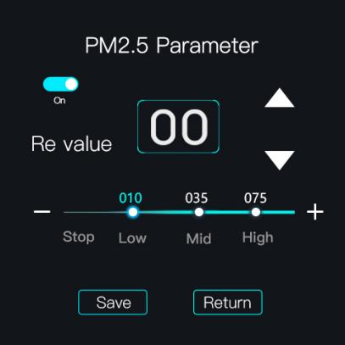
In the PM2.5 parameter setting interface, set return value, low, medium and high value. When the PM2.5 value switch button is turned on, the fan will switch to the fan gear according to the PM2.5 value in the automatic mode. When it is turned off, the fan will not be affected by the PM2.5 value in the automatic mode.
When the PM2.5 button is turned on, in the automatic mode, the PM2.5 value is greater than the set value, the fan operates at the corresponding gear, when the fan speed changes from high gear to low gear, PM2.5 value should be lower than setting value minus return value.
- VOC parameter setting interface: as shown below
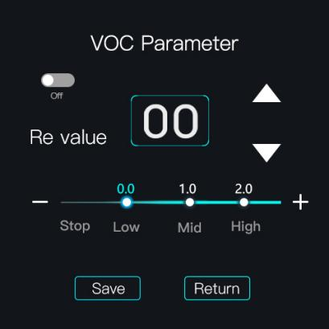
In the VOC parameter setting interface, set return value，low, medium and high value. When the VOC value switch button is turned on, the fan will switch to the fan gear according to the VOC value in the automatic mode. When it is turned off, the fan will not be affected by the VOC value in the automatic mode.
When the VOC button is turned on, in the automatic mode, the VOC value is greater than the set value, the fan operates at the corresponding gear, when the fan speed changes from high gear to low gear, VOC value should be lower than setting value minus return value.
11.Language switch setting interface: as shown below
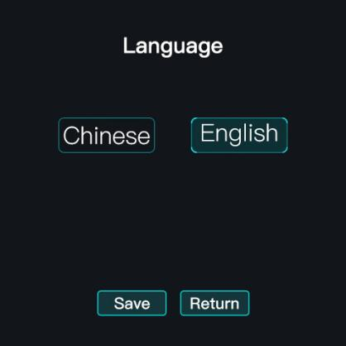
Language selection, you can choose Chinese or English.
12.Fault interface
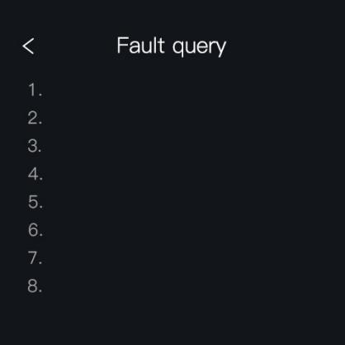
When there is a fault, a small fault icon will be displayed in the upper right corner of the main interface. When there is no fault, the small icon will not be displayed.
13. Press the Return key in the menu interface to return to the previous interface. In the non WIFI setting interface, it will automatically return to the main interface after 1 minute of no operation.
14. If there is no key operation for 1 minute on the main interface, the screen will turn off. When the screen is turned off, when touch the screen, the backlight will light up again.
15. This controller is connected to an AC fan motor, and an AC damper, and RS485 communication.
16. The device 485 address can be modified. The device address range is 1~254. The default value is 1.
17. PM2.5 will enter intermittent operation if there is no key operation for 5 minutes. During intermittent operation, PM2.5 is turned on for 60 seconds and off for 4 minutes.

4. Technical parameter:
* Dimension: 86×86×52.5mm * Warm-up time: 2 minutes
* Fixing hole distance: 60mm(standard) * Response time: ≤10 seconds
* Wiring terminal: Max 2.5 mm2 wire * Recovery time: ≤30 seconds
* Rated voltage: AC110V - - 220V, 50HZ * Operation temperature: -10℃ --- +50℃
* Standby Power: ≤2.0W * Operating humidity: 5％RH——90％RH(No condensation)
* Control Power: about 200W * Storage temperature: -10℃ --- +60℃
* Output interface: AC 3 speed * Storage humidity: ≤60％RH
* Temperature display range: 0℃— 99℃ *Life: ≥ 3 years
* CO2 display range: 350ppm – 5000ppm (optional)
* PM2.5 display range: 1ug/m3——999ug/m3
5. Wiring diagram:
